

STILER

User Guide 1.0



STILER

User Guide 2.0

**Version Information**

|  |  |  |  |
| --- | --- | --- | --- |
| **Version Number** | **Modified By** | **Modifications Made** | **Date Modified** |
|  |  |  |  |

|  |  |
| --- | --- |
| **STILER Leadership** | |
|  |  |
|  |  |
|  |  |
|  |  |

|  |  |
| --- | --- |
| **Technical Team** | |
|  |  |
|  |  |
|  |  |
|  |  |
|  |  |
|  |  |

Table of Contents

1 At a Glance 3

1.1 Overview 3

1.2 Scope 4

1.3 Audience 4

1.4 Overview of features: What can it do for you? 4

2 Getting Started 5

2.1 Introduction to Stiler utility 5

2.2 Features of Stiler utility 6

2.3 Before you begin 7

2.4 Reporting Flow 7

2.5 First Time Use 7

3 Reports 10

3.1 Dashboard 10

3.2 Complete Report 11

4 Deloitte Survey Tool 16

4.1 Survey Template 16

4.2 Functionality of Deloitte Survey Tool 17

5 Settings 20

5.1 Restricted Codes 20

5.2 Staffit Template 21

5.3 DTE Template 22

5.4 Update Manager/Counselor Details 23

6 Response Analysis 25

# At a Glance

The purpose of this chapter is to provide an overview on the different features of Stiler and an overall understanding of the tool.

## Overview

The Utility assists in creating a report of practitioners who are currently staffed on a client project but are not charging aptly on DTE. Using the analyzed report, an auto triggered mail is sent to the practitioners informing them about the variance between their STAFFIT & DTE as it affects the overall Utilization.

The utility analyses the imported time records and provides valuable insights into the variance leveraging cognitive functionalities, modular design and an intuitive user interface

It then auto-triggers an email to the practitioner on detecting a time leakage while looping in the Project Manager & Counselor.

## Scope

Numerous practitioners default in filling timesheets by not submitting the timesheet or charging to an incorrect WBS code. Resource Managers (RM) take nearly 4-5 days to manually assess the leakage, after which they follow-up with the practitioners manually via email. The Stiler utility is a one-stop go to solution which enables RMS to plug in timesheet exports, generate analytical reports and trigger personalized mails to practitioners keeping in loop their Managers and Counselors. The responses of the practitioners can be further used in the utility to generate trend charts by operational metrics.

## Audience

The Stiler utility is simple yet comprehensively designed to help Resource Managers, Project Managers, Counselors, HR and Talent Team and other senior management. It aids in understanding discrepancies by providing visual dashboards and reports. With the ability to trigger mails, it allows senior management the ability to efficiently collect responses and address the root causes of time leakage.

## Overview of features: What can it do for you?

Features of the tool include:

• Generate reports based on selection of year and week number

• Display percentages of compliant and non-compliant practitioners

• View generated report in detailed and summarized forms

• Trigger personalized mails for all non-compliant practitioners

• View previously generated reports

• Provision to capture practitioners’ responses and consolidate

• Generate trend charts from practitioners’ responses

• Modify list of restricted codes and manager/counselor details

• Download timesheet templates

The later chapters will go through all the above-mentioned features in detail.

# Getting Started

## Introduction to Stiler utility

Being able to keep track of whether you are making or losing money on a project is one of the most important benefits of using timesheets. If we’re providing a client a fixed-fee, we should be able to monitor how much time is being spent on a project (and the spend-per-hour), so that there is no loss of revenue.

The end result of this utility is:

* Billing clients correctly
* Tracking project costs
* Planning HR
* Estimating future costs
* Measuring unproductive time
* Understanding employees’ workload

The utility allows for Managers to upload timesheet exports from DTE and STAFFIT, select year and week numbers to compare, which leads to the analysis being executed and a report is generated. The concerned authority can then view the proportions of compliant and non-compliant practitioners. One can then view the report in a summarized pivot form or in detail. Upon triggering the send mail option, personalized mails are sent to all non-compliant practitioners. The user can also view reports generated in the past.

Benefits of using this utility are:

* Reduced Manual Effort
* Robustness
* Reusability
* Efficient Processing
* Process Failure Aversion
* Cost Effectiveness

## Features of Stiler utility

• **Generate Reports Based on Selection of Year and Week Number**: Provides an end-to-end variance analysis solution by allowing for picking desired year and week numbers for the timesheet exports uploaded

• **Display percentages of compliant and non-compliant practitioners**: Computes the proportions of practitioners charging correctly to client and those otherwise

• **View generated report in detailed and summarized forms**: Makes reports in consumable forms through summarized pivot table format, and in a comprehensive table consisting of all fields contributing to variance

• **Trigger personalized mails for all non-compliant practitioners**: Personalized emails are sent out to all compliant practitioners with details like Period, Week number and Duration and a linked that is used to centrally capture responses of practitioners to further analyze

• **View previously generated reports**: View reports that were generated in the past and send out mails for them

• **Provision to capture practitioners’ responses and consolidate**: Allows for capturing responses through a survey and export to excel spreadsheets

• **Generate trend charts from practitioners’ responses**: The responses of the practitioners can be fed in the utility again to analyze trends in the responses

• **Modify list of restricted codes and manager/counselor details**: Permits modifying list of charge codes to include other ones, and details of manager and counselor in the event of management changes

• **Download timesheet templates**: The templates of DTE and STAFFIT exports are available as downloadable links

## Before you begin

To use the STILER utility, you need:

• Authorization to use the tool

• Authorization to view timesheet exports

• Authorization to send out emails to practitioners

• Access to the survey on Deloitte Survey Tool

• Exports of DTE and STAFFIT data

**Note:** For the bestuser experience, we recommend using Internet Explorer or Edge web-browsers, view set at 100% (Go to View > Zoom), and the screen resolution set at 1920 X 1080 ([?](https://support.microsoft.com/en-ca/help/4026956/windows-10-change-screen-resolution))

## Reporting Flow

**Step-1 Report Generation:** The report is generated by picking the DTE and STAFFIT exports and selecting year and week number

**Step- 2 Consumption of Analysis:** The report is displayed in detailed and summarized forms for quick utilization

**Step- 3 Sending Email and Collecting Responses:** Mails are sent out to practitioners and responses are collected

**Step- 4 Trend Analysis:** Export of the responses are used to analyze trends of responses

## First Time Use

To use the Stiler utility for the first time, perform the following steps:

1. Run the bundled executable file
2. Go to <http://127.0.0.1:5000/home> on the web-browser
3. The home screen is displayed

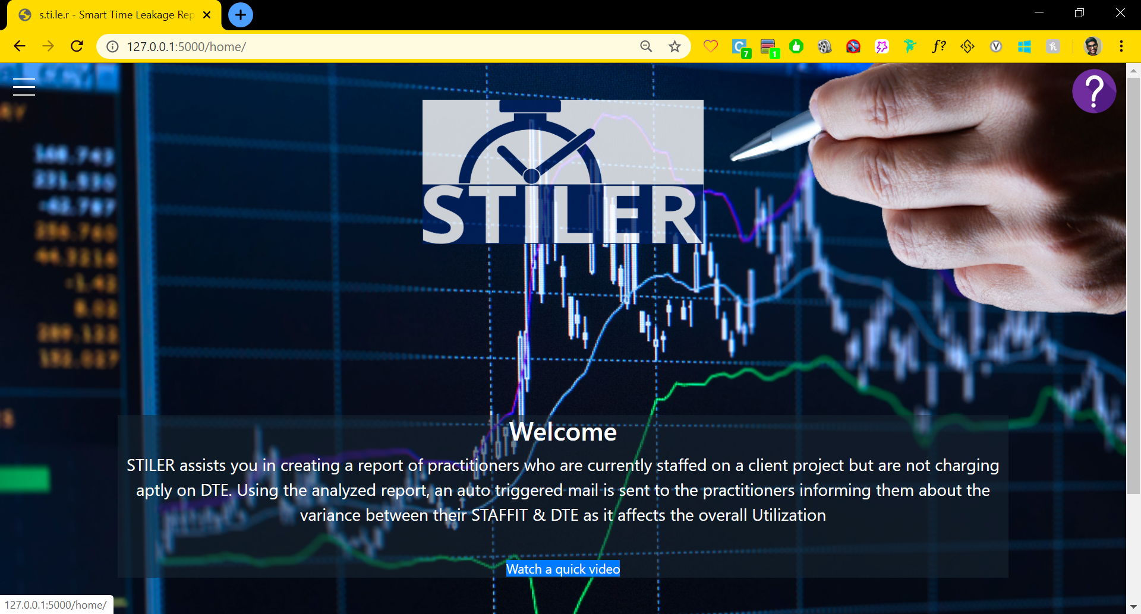

Figure .

1. Click on the hamburger menu on the top left corner of the page to reveal navigation menu

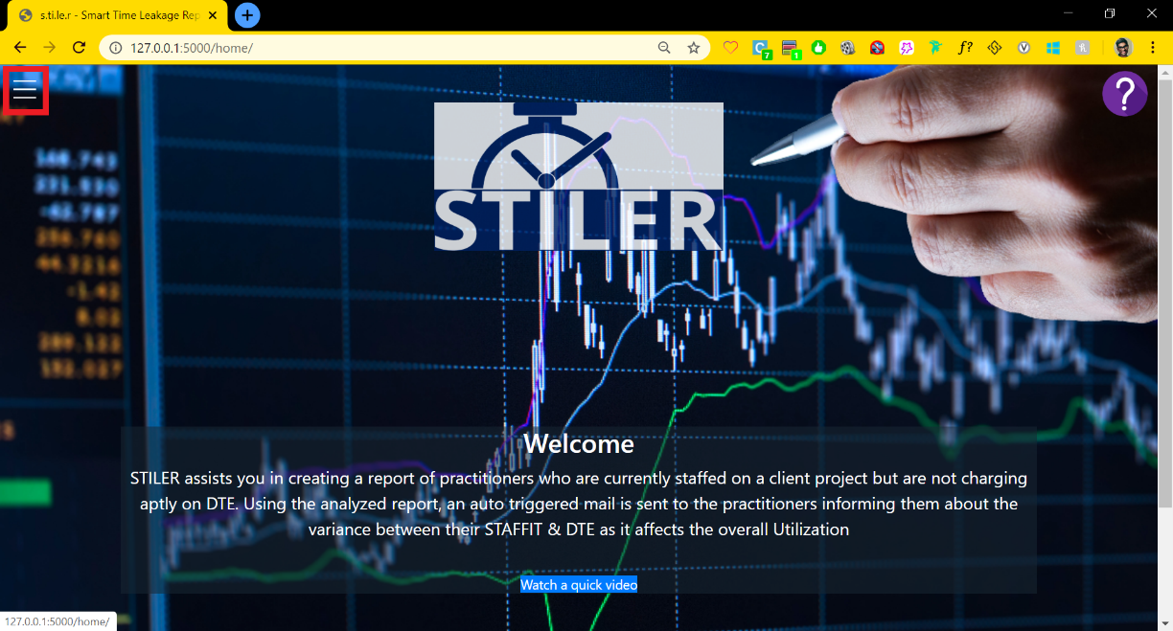

Figure .

1. Click on the **Reports** in the navigation pane

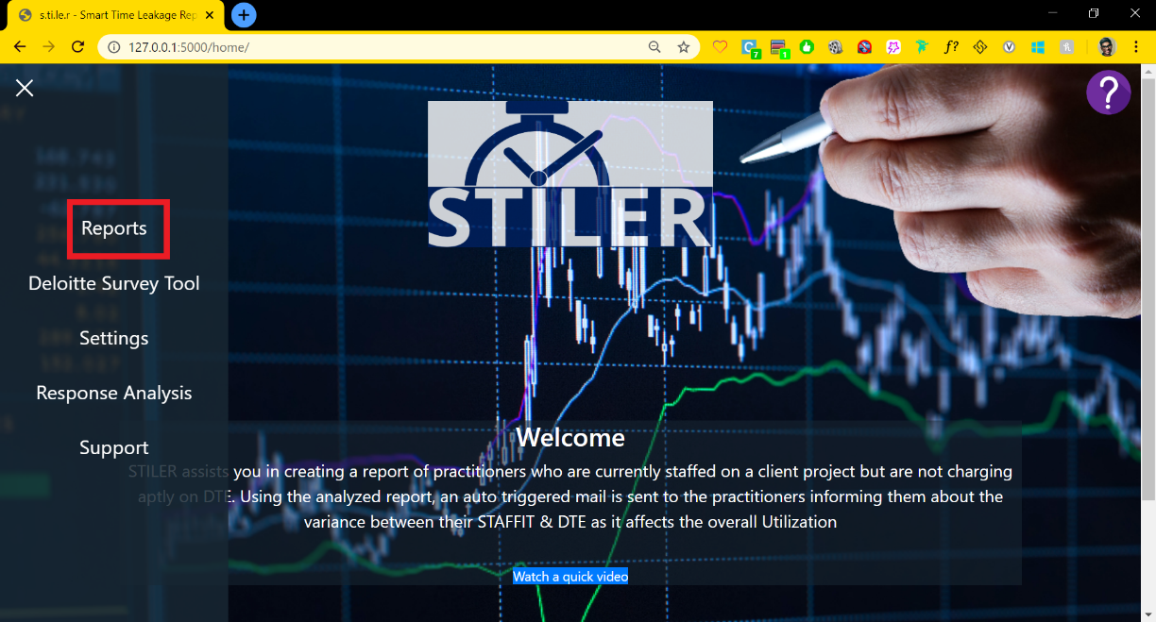

Figure .

1. Select the DTE and STAFFIT exports by clicking on their respective buttons and pick the excel spreadsheets using the file manager. Select the year from the dropdown and enter the desired week number for analysis

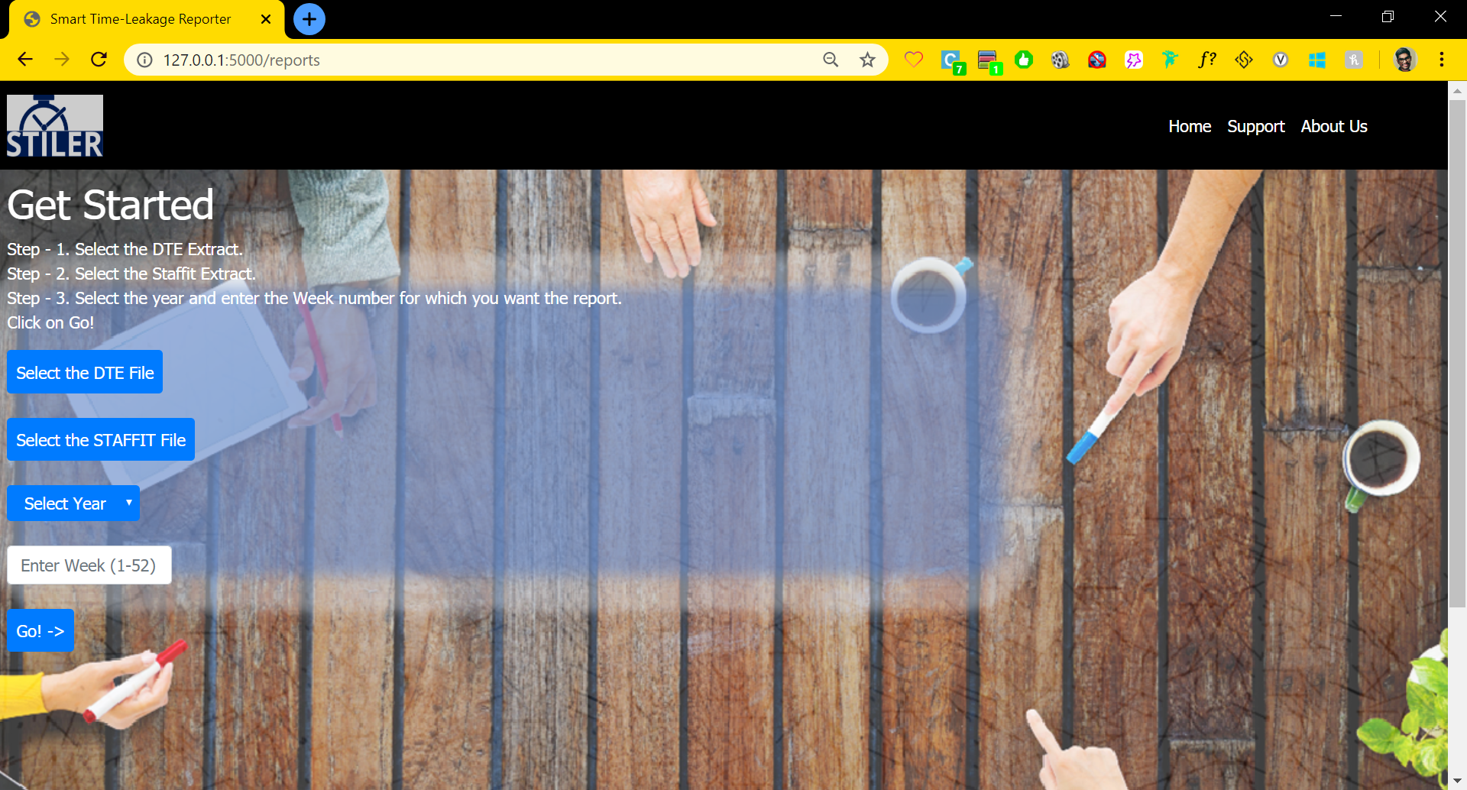

Figure .

1. Your first variance report is generated. Click on View Complete Report to open the report in Excel. Click on Send Emails to send emails to non-compliant practitioners.

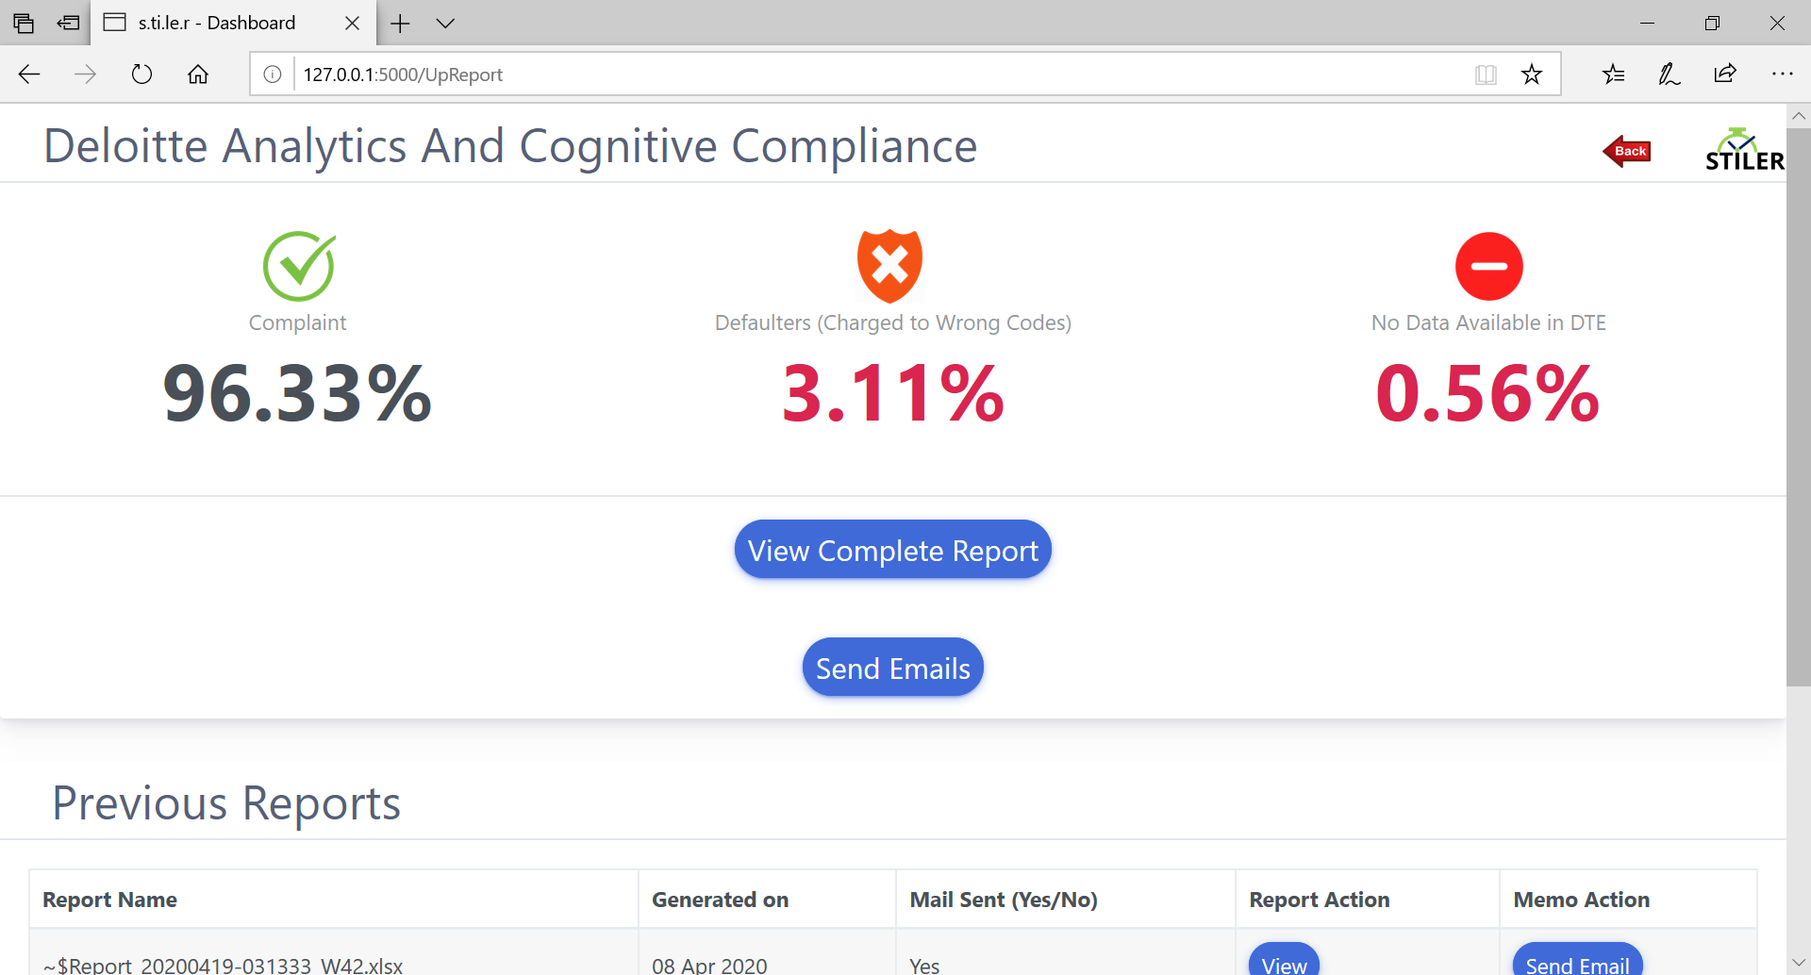

Figure .

# Reports

This chapter will cover the contents of the complete Report that was generated in the previous section as well as demonstrate the features of the dashboard that enable the user to send mails to defaulters and gives an insight into the variance analysis.

## Dashboard

The dashboard contains the below listed features as seen in the *Figure 3.1*:

* Variance Analysis Statistics gives the percentage of practitioners as below:
  + Compliant in submitting timesheets
  + Charging to an incorrect DTE Code as opposed to what is forecasted in the STAFFIT
  + Missed submitting the timesheet for that week
* The Report containing the details of all the practitioners and their variance can be viewed by clicking “View Complete Report”. We will discuss more on this in the next sub-section
* “Send Emails” button can be clicked to send variance emails to all the defaulters identified
* The Previous Reports section gives details as mentioned below:
  + Names of the previously generated Reports
  + Date of the Report generation
  + Indicator to let the user know if Variance Emails were sent for that Report
  + The Report can be viewed by clicking on the button under “Report Action”
  + If a Variance Email must be sent for a previously generated Reports, the user can click on “Send Email” button under “Memo Action”

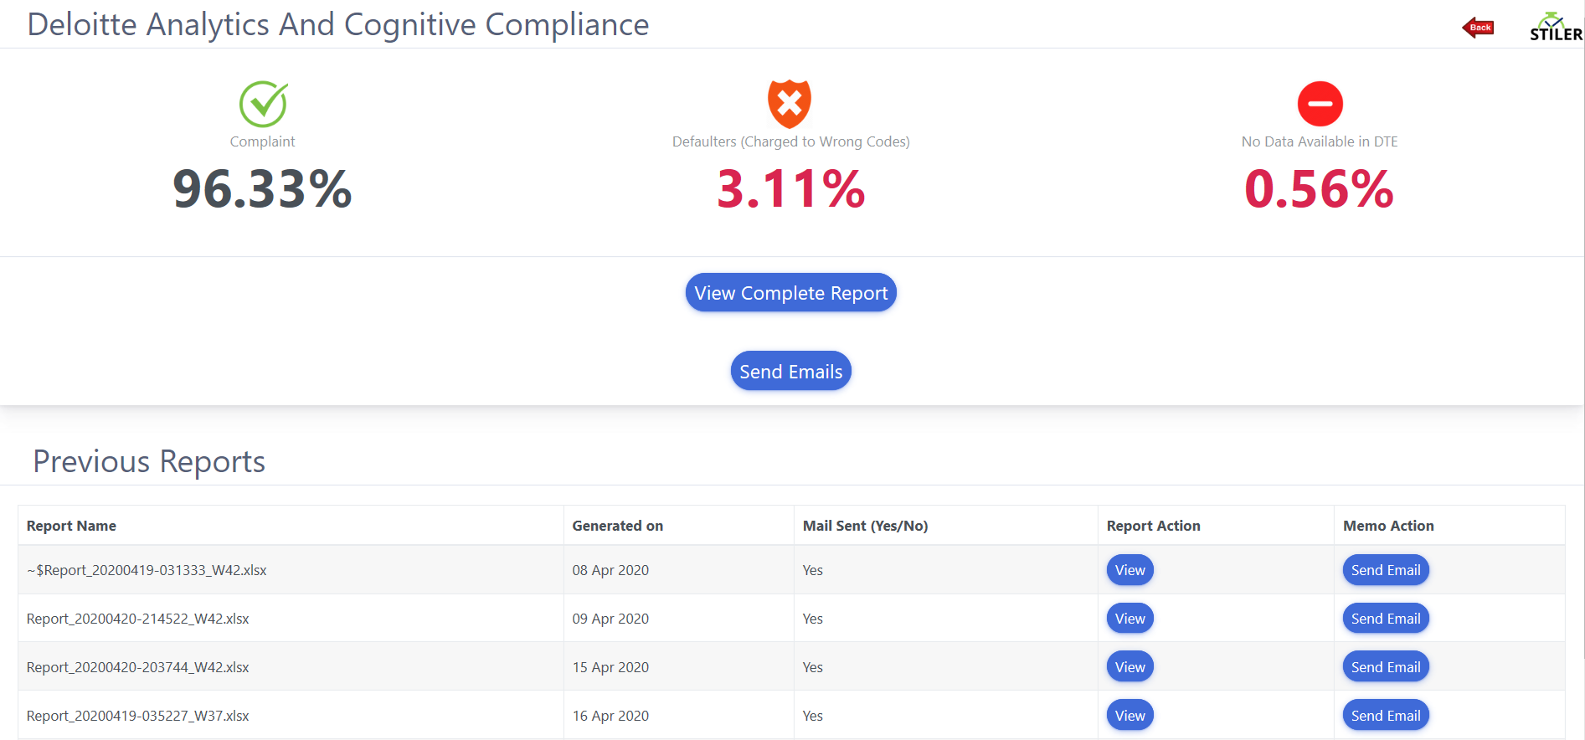

Figure .

## Complete Report

The Report generated can be viewed by clicking on “View Complete Report” button available on the dashboard. This Report contains 4 tabs, namely:

* Op_Variance_Data
* ReportbyCategory
* PivotTable
* DTE Report



Figure .

### Consolidated Report

The consolidated Report is available in the tab named “Op_Variance_Data”. This sheet contains Practitioner level details available in both the STAFFIT and DTE Reports. Let us look at the columns available in this sheet:

* Columns A – H: Information about the practitioners like Name, Email_id, Project Name, Location, Billing Status and other RM details are available here
* Column I: This contains the week number for which the Report was generated
* Column J – Z: Contains the hours charged by the Practitioner in DTE against each DTE code available
* Column AA: This is the sum of the total hours charged by the Practitioner for that week
* Column AB: Client service hours forecasted in STAFFIT for that week
* Column AC: The variance is “Yes” if the Practitioner has charged to any of the restricted DTE Codes he should not be charging to. The variance is “No” if the Practitioner has not charged to any of the restricted DTE Codes or is a part of the Management
* Column AD: Send_Email is “Yes” if the variance is “Yes” in Column AC. Else it is “No”
* Column AE: Reason_For_Variance contains 3 distinct values. These are:
  + Not Applicable – If there is no time leakage observed for the Practitioner
  + Variance – If Variance is “Yes” in Column AC
  + Not Available(DTE) – If the Practitioner has not charged any time on DTE for that week
* Column AF: This column tells us if the Practitioner has charged time to “GAA”, “Holding Tank”, “FPX” or is a part of the Management

### Report by Category view

The summary of the consolidated Report can be viewed at multiple granularities in the sheets named “ReportbyCategory” and “PivotTable”. Let us look at these views in detail:

#### Report by Billing Status View

There are two views available in the “ReportbyCategory” sheet for Report by Billing Status. These views are as follows:

* Total Hours available in the DTE for all the codes by the distinct Billing Status. There is a filter option as well as the top left corner to display the view as per the offering selected

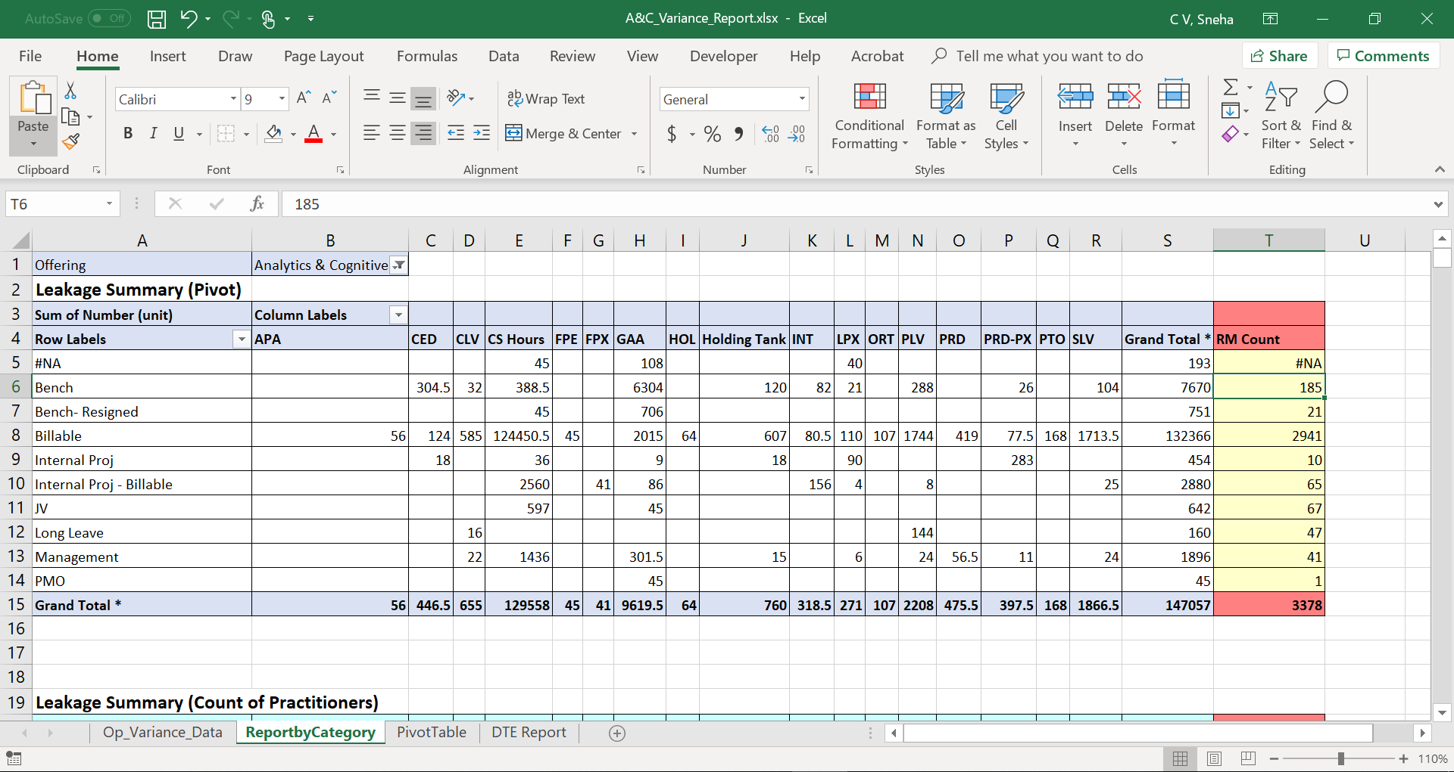

Figure .

* Total number of Practitioners who submitted time against each DTE Code by the distinct Billing Status

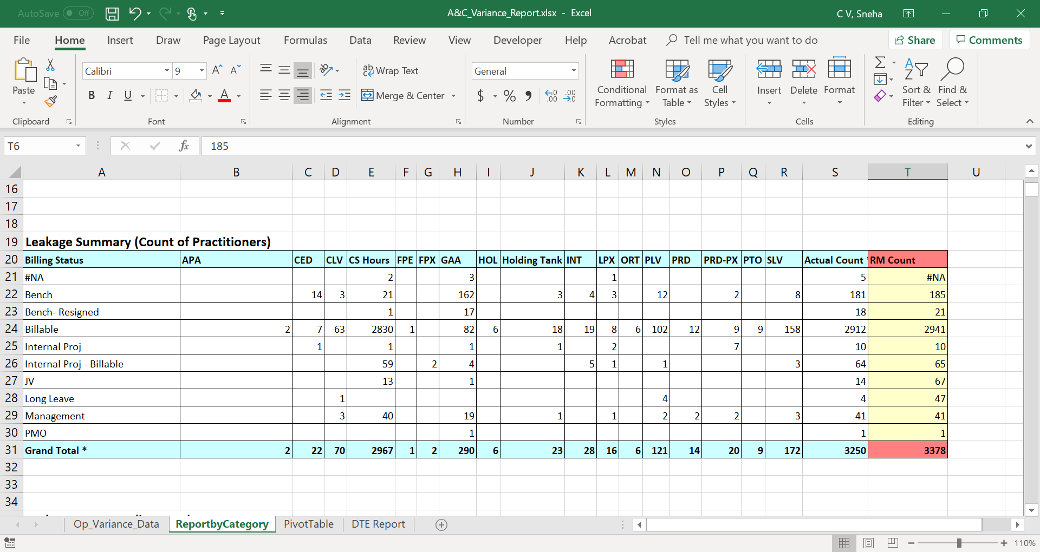

Figure .

#### Report by DTE Category & Project View

This is a summary of the total Client Service hours available in STAFFIT & DTE Reports along with the count of Practitioners. This table can be viewed at multiple granularities. Namely:

* Location level: The filter available at the left-hand corner of the sheet contains a list of distinct locations available in the DTE Report. This can be used to view the summary table as per the selected location
* Category level: This contains the distinct values available in Column AF of the consolidated Report present in the “Op_Variance_Data” sheet of this document. The explanation of this column was covered as part of section 3.5.
* Request Name level: This column contains the project name of the billable practitioner/ practitioners who have charged to the DTE Codes FPX, GAA, Holding Tank or a part of the Management

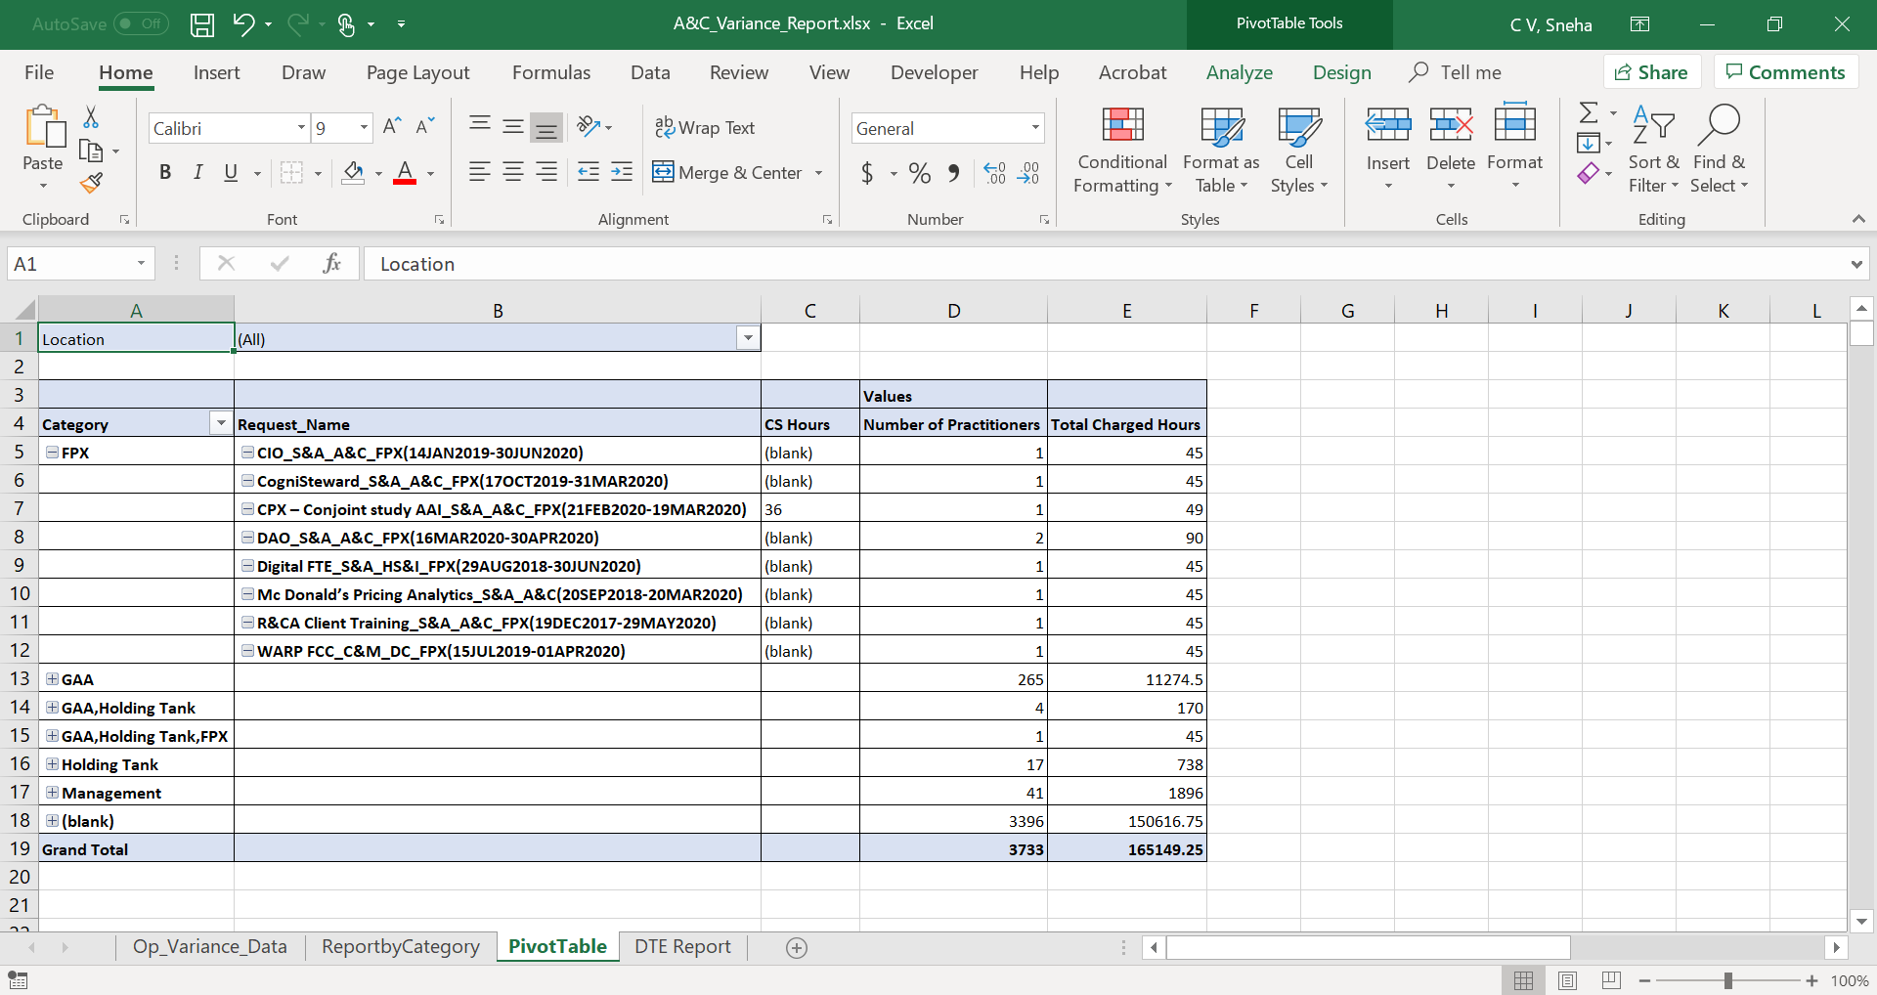

Figure .

# Deloitte Survey Tool

This chapter covers the template of the survey which will be shared with the defaulters to capture their reason for time leakage and also the step by step process of accessing the survey results and downloading them. Let us look at these processes in more detail.

## Survey Template

There is a button named “Send Email” available next in the dashboard after generating the complete Report. On clicking this, an email is triggered to the identified defaulters with a link to a survey that must be filled with the reason for time leakage and submitted.

The template of the survey can be seen in *Figure 4.1*. The 6 fields that must be duly filled by the practitioner are as follows:

* Name of the Practitioner
* Email ID
* Personnel Number
* Response Type – One of the 8 options must be selected by the Practitioner
* Week Number – The format of the week number entered must match with the format provided in the Email
* Comments – The Practitioner can provide additional details on the response type selected

The link to access this survey – [Here](https://deloittesurvey.deloitte.com/Community/se/3FC11B2676A47B94)

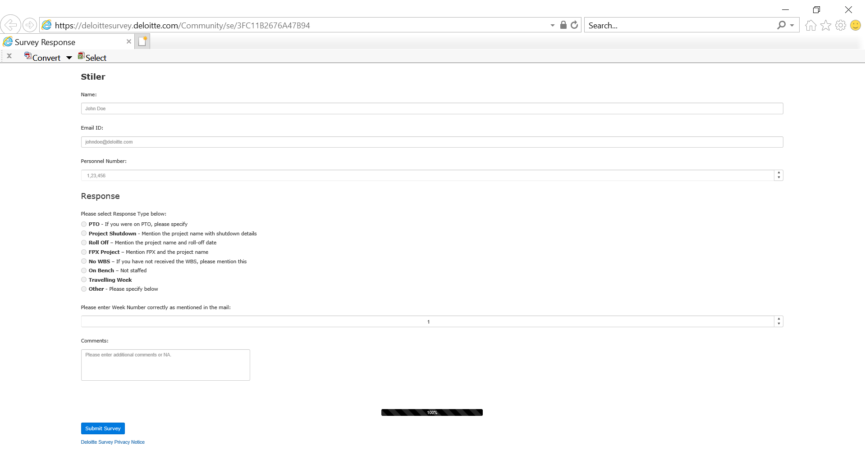

Figure .

## Functionality of Deloitte Survey Tool

This section covers the steps involved in using the Deloitte Survey Tool to view the responses from the practitioner who have submitted the survey and download them.

* On the homepage, the user can click on the left corner button present on the screen to access the below list of features. Click on “Deloitte Survey Tool” as seen the *Figure 4.2*

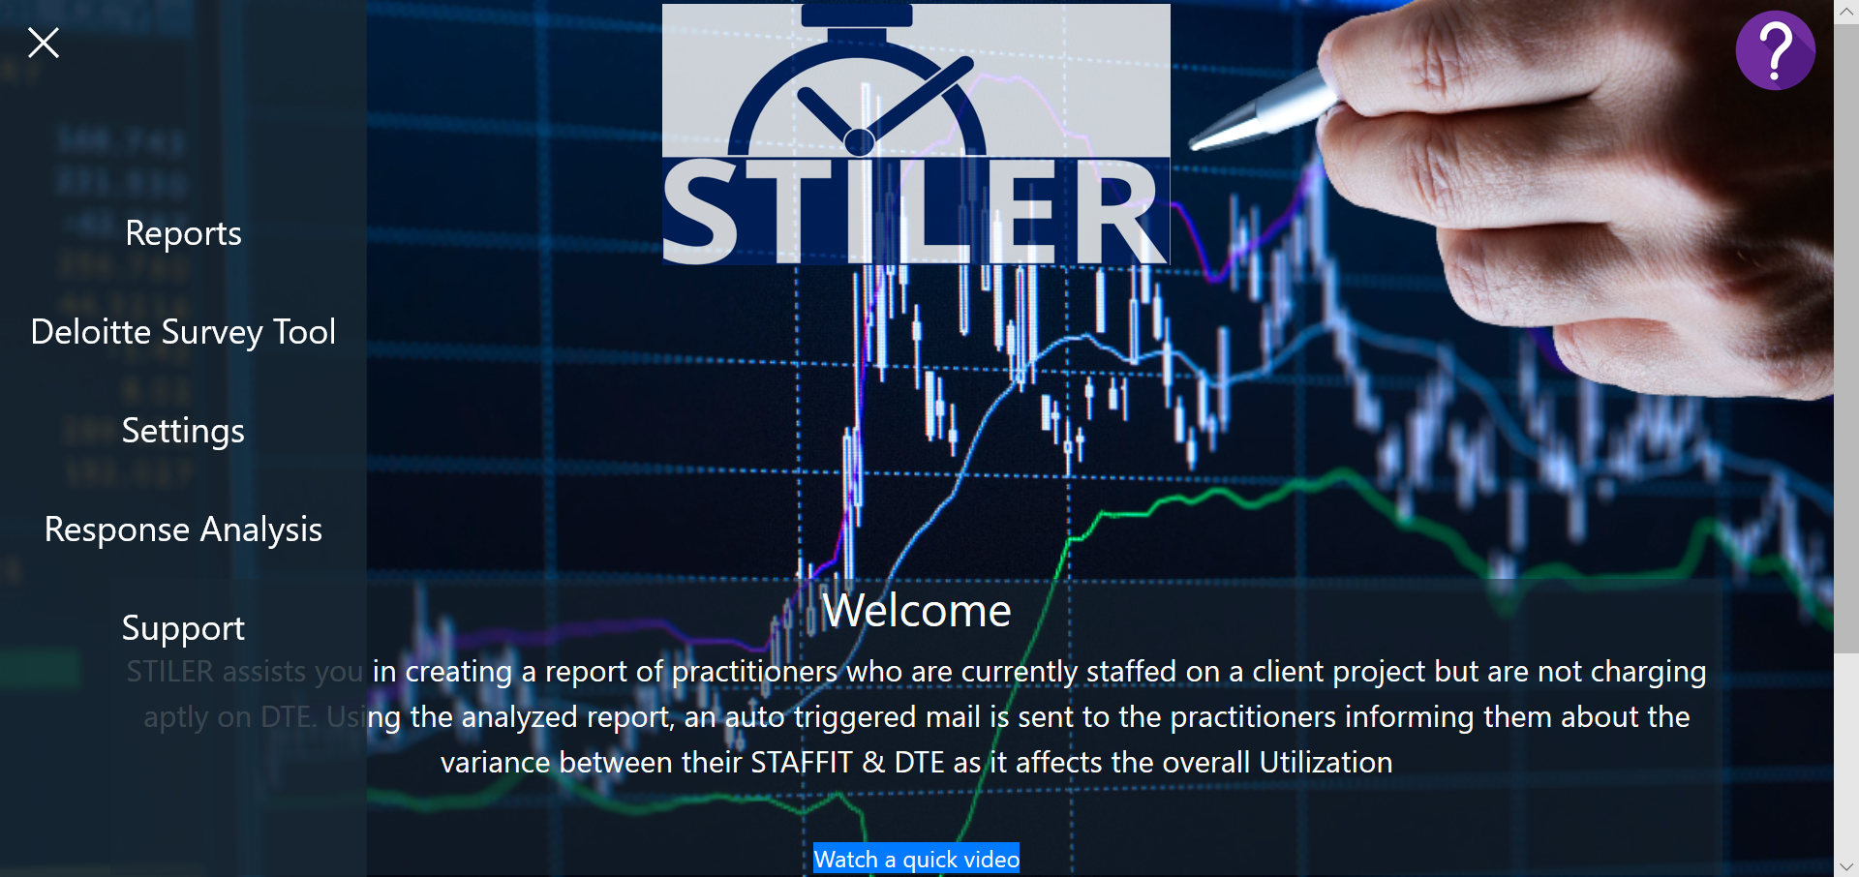

Figure .

* Click on the “Analyze” tab and “View Responses” button that is highlighted in the below *Figure 4.3*

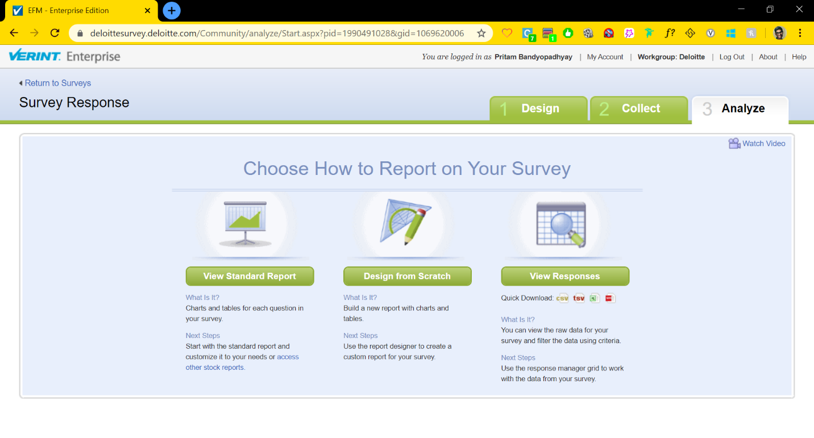

Figure .

* Select the responses from the Practitioner that must be exported

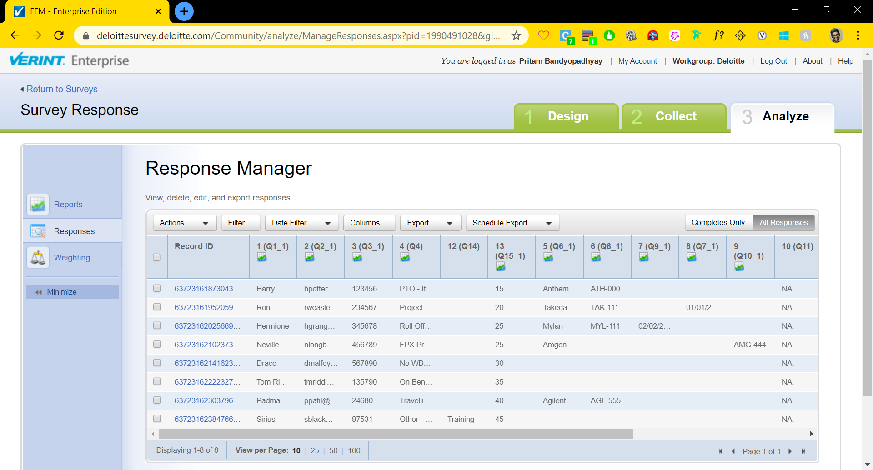

Figure .

* Click on Export and choose “Microsoft Excel” to export the responses

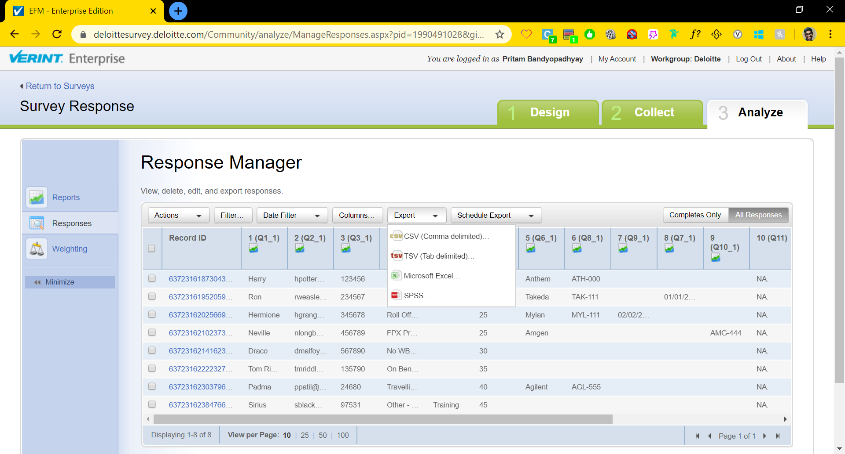

Figure .

* A read only excel sheet will be open with all the responses selected in the Deloitte Survey Tool

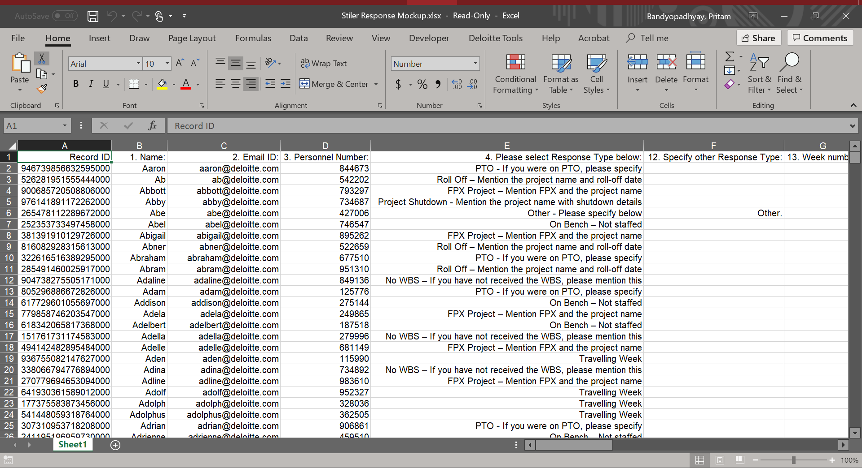

Figure .

# Settings

This chapter covers the options available under settings to equip the user to customize the list of DTE Codes by adding or deleting them, update the details for managers or counselors through the template provided in the Settings page and also download the DTE/STAFFIT templates.

On the homepage, the user can click on the left corner button present on the screen to access the below list of features. Click on “Settings” as seen the *Figure 5.1*

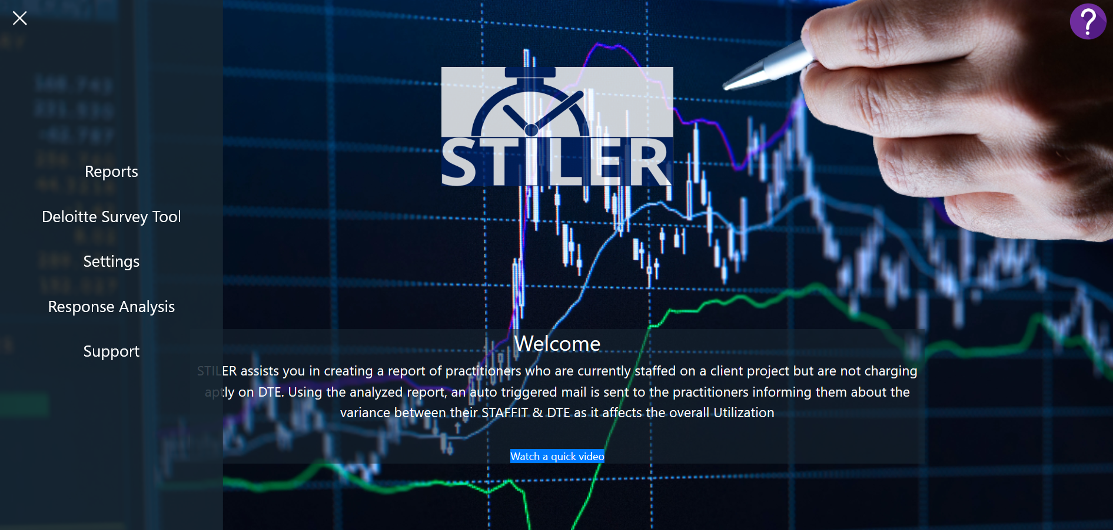

Figure .

## Restricted Codes

There is a list of DTE codes that a billable Practitioner should not charge to while submitting the hours on DTE. These codes are considered to be restricted codes. The time leakage between STAFFIT and DTE is calculated based on these set of codes for every practitioner. This list is highlighted in the below *Figure 5.2* for your reference. The below two operations can be performed to customize the list of restricted codes:

### Deletion of Restricted Codes

The desired DTE code can be deleted by clicking on the respective “x” mark. These changes can be saved by clicking on the “SAVE” button

### Addition of Restricted Codes

A new DTE code can be added to the existing list of Restricted Codes by entering the name in the text box provided and clicking on enter. These changes can be saved by clicking on the “SAVE” button

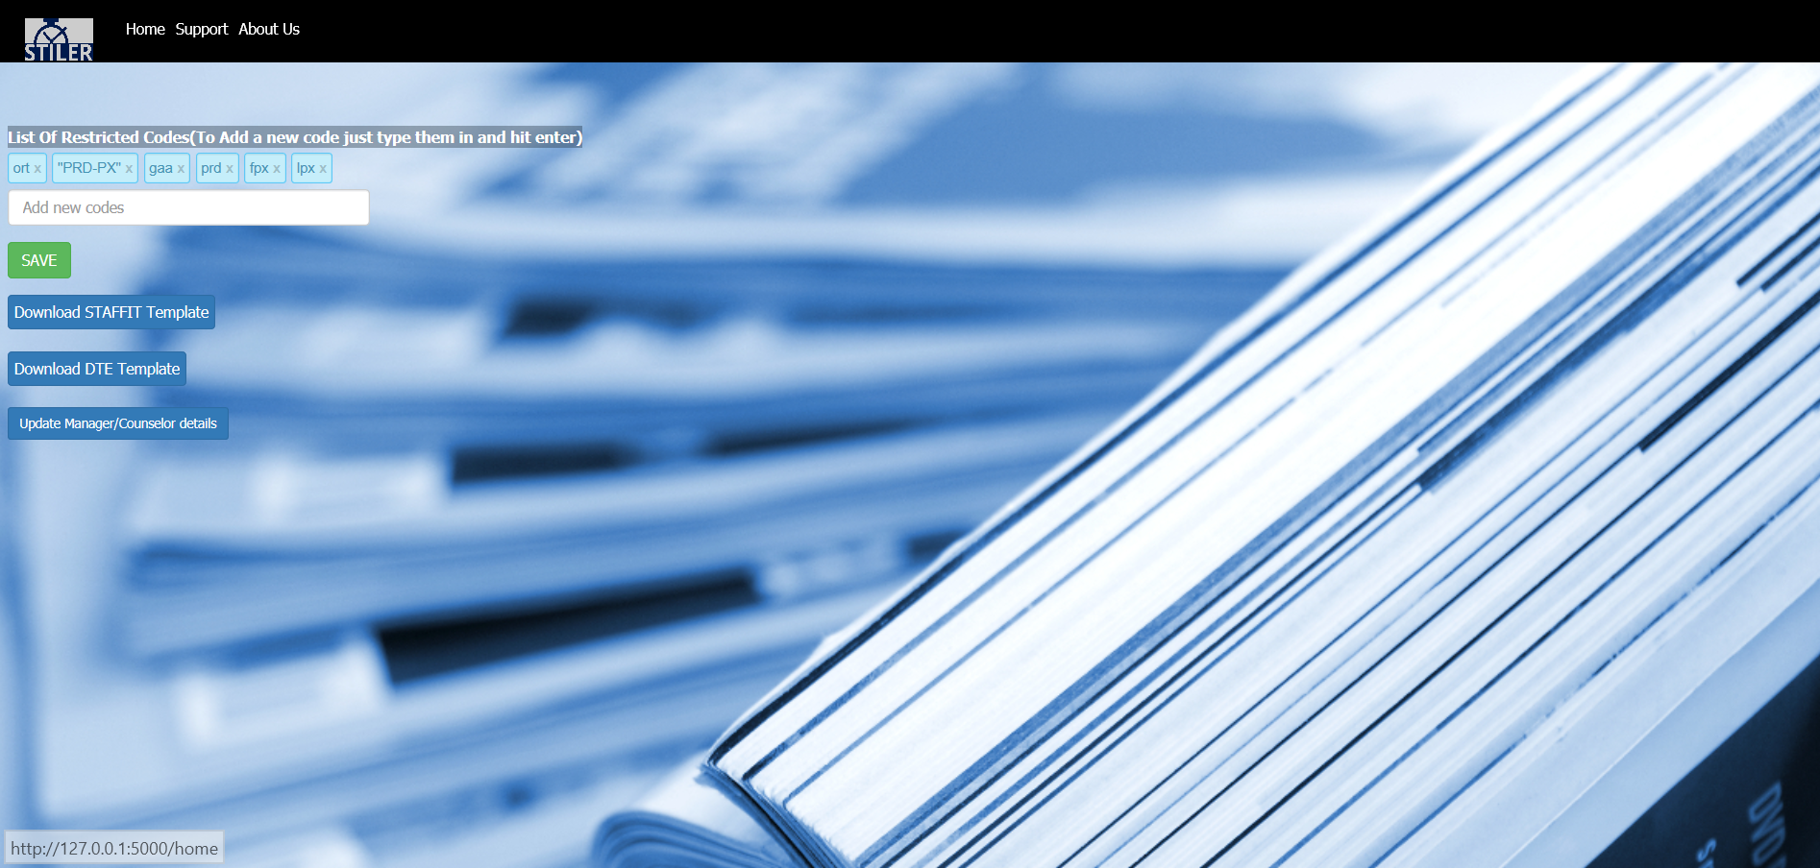

Figure .

## Staffit Template

The STAFFIT Template that is compatible with the tool can be downloaded by clicking on the button highlighted in the *Figure 5.3*



Figure .

An excel file with the name “Staffit_template.xlsx” containing the template is opened. The data can be copied to this template as per the column headers. However, it is important to copy the column headers as well for columns “BC” to “BN” as these headers contain the week ending dates.

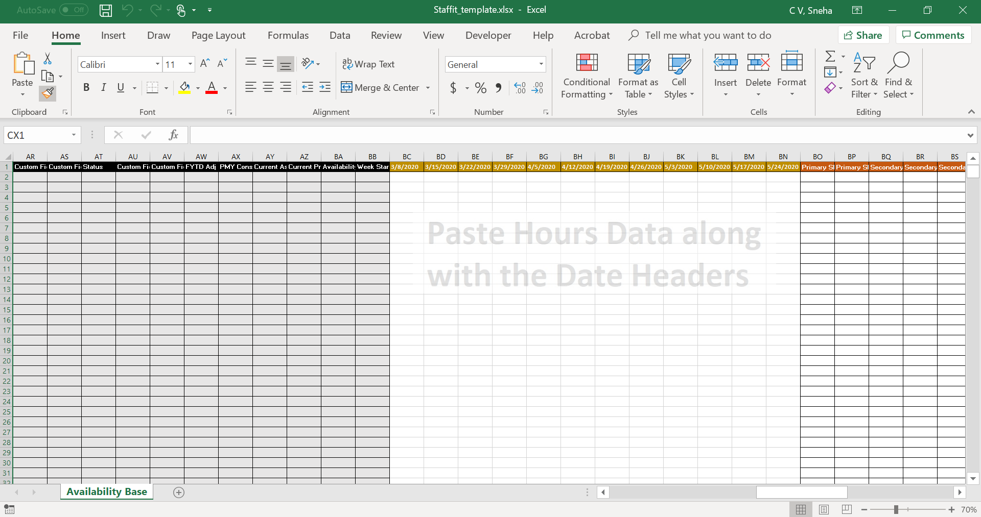

Figure .

## DTE Template

The DTE Template that is compatible with the tool can be downloaded by clicking on the button highlighted in the *Figure 5.5*



Figure .

An excel file with the name “DTE_template.xlsx” containing the template is opened. The data can be copied to this template as per the column headers.

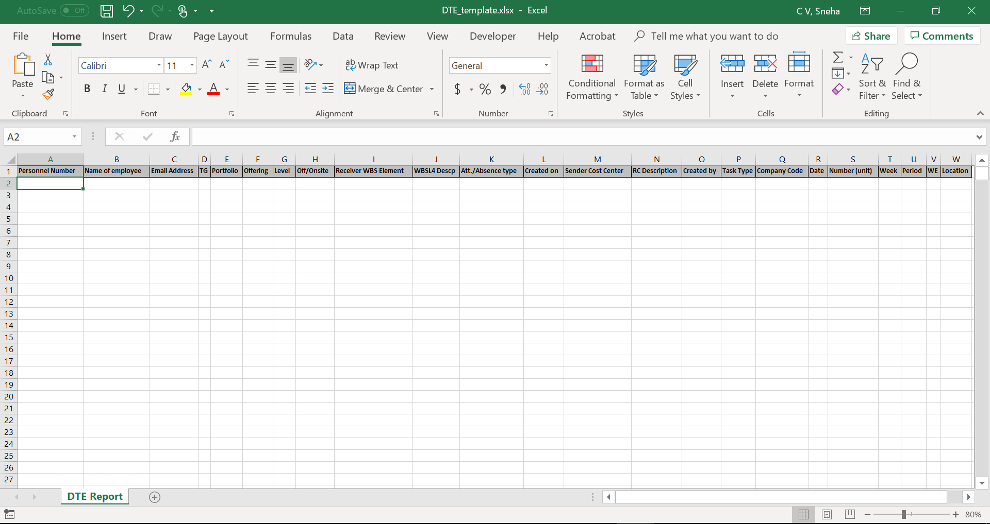

Figure .

## Update Manager/Counselor Details

The Update Manager/Counselor Details Template that is compatible with the tool can be updated in the excel file that opens on clicking the button highlighted in the *Figure 5.7*



The required details can be added in below template and saved. These changes are automatically reflected in the tool on saving the updated excel file.

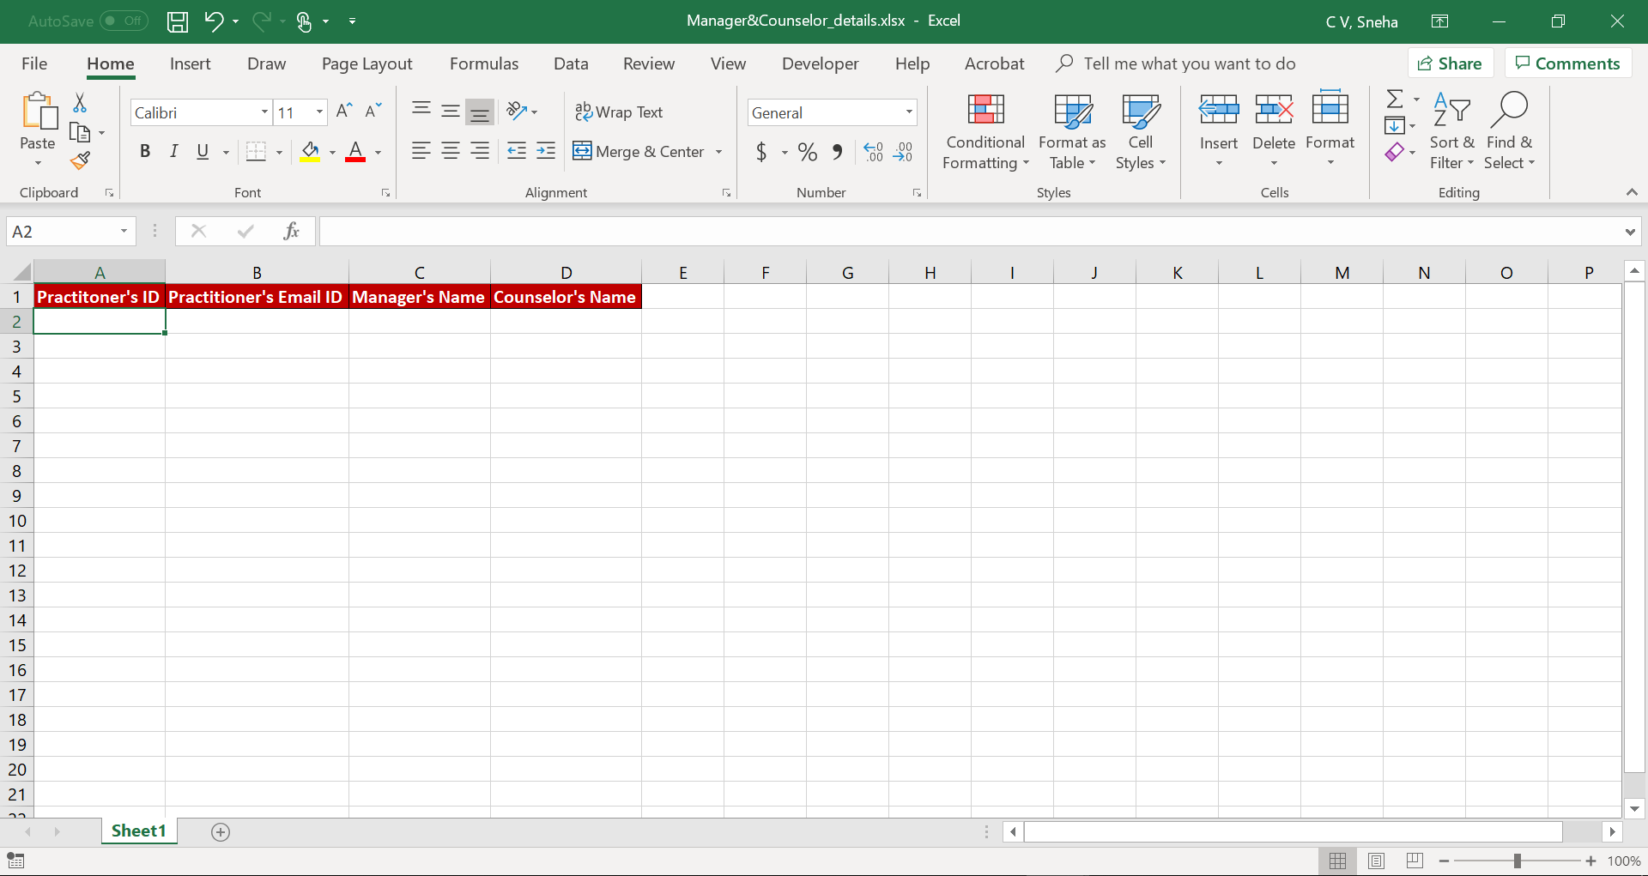

Figure .

# Response Analysis

The Response Analysis page gives us valuable insights into the Time leakage analysis across multiple metrics. We will this in details as part of this section.

On the homepage, the user can click on the left corner button present on the screen to access the below list of features. Click on “Response Analysis” as seen the *Figure 6.1*

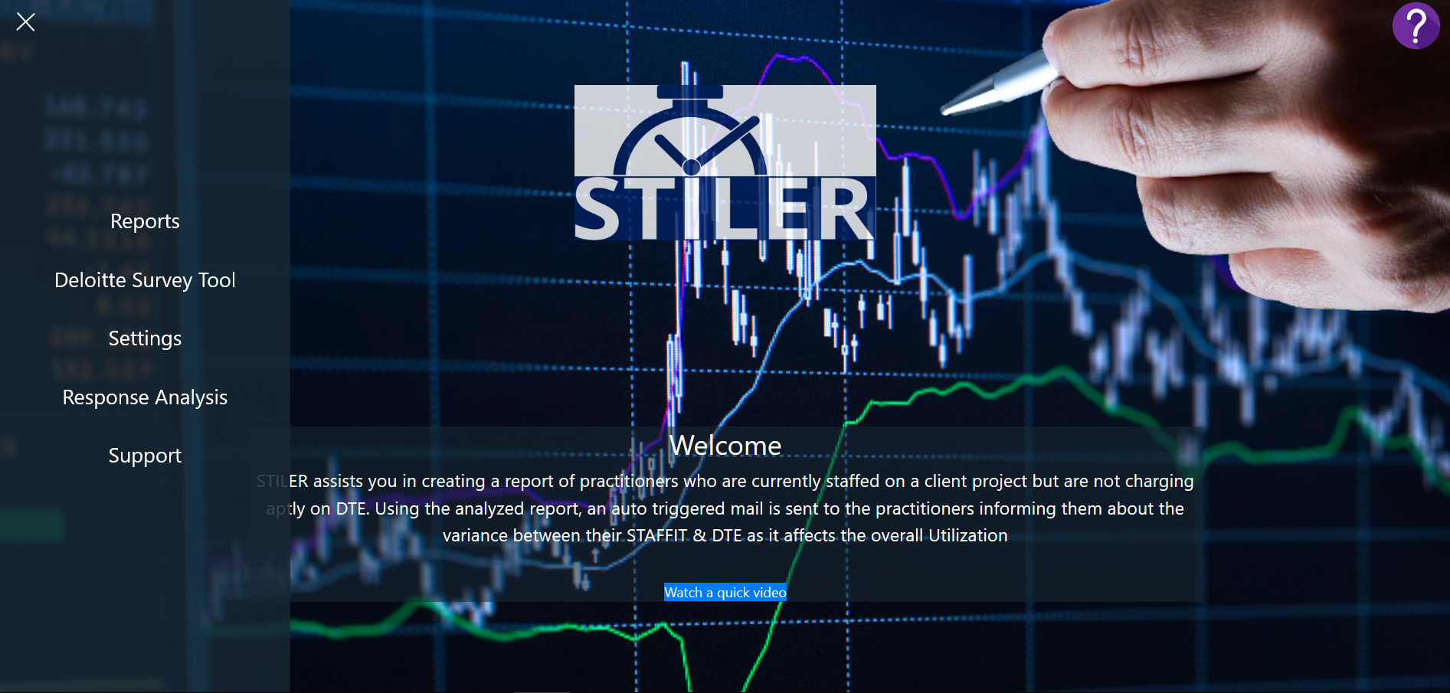

Figure .

Some of the visualizations that are included as part of this page are:

* #Hours of time leakage by Project

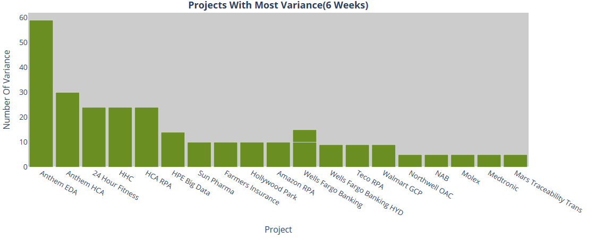

Figure .

* #Hours of time leakage by Week

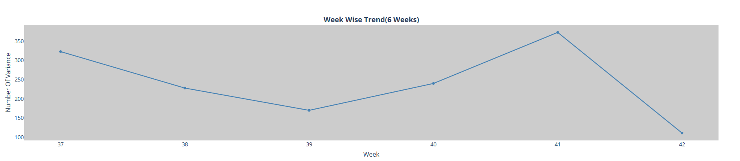

Figure .

* The trend that is generated based on the responses captured from the defaulters

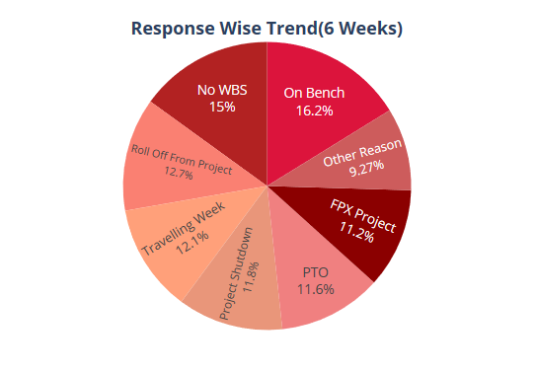

Figure .